Use cases, Flowchart & Design Document For LOCK, UNLOCK & LOCK EXISTING EXE and Add-In
Software Requirements :-
- TIA Portal V18 with TIA Openness
- Add-In file placed in:
C:\Program Files\Siemens\Automation\Portal V18\Addins\LockUnlockBlock.addin
- Protect Block application folder placed at:
C:\Protect Block\Debug
- For more details, please refer to the LockUnlockBlockaddin.mp4 video link

Use Cases: -
Use Case 1: Protect TIA Portal Block (LOCK)
Precondition:
- TIA Portal is already open
- Target project is loaded
- Valid license is available
Trigger:
User runs the automation with action = LOCK
Main Flow:
- User launches the EXE/Add-In with project name and LOCK action.
- System validates the license using LicenseManager.
- TIA Portal window is hidden automatically.
- Automation opens the Protection tab of the selected block.
- Write protection is enabled.
- Password is entered and confirmed automatically.
- Protection is successfully applied.
- TIA Portal window is restored.

Postcondition:
- Block is write-protected with password.
- No manual interaction required.
Use Case 2: Remove Protection from Block (UNLOCK)
Precondition:
- Block is already protected
- Correct password is configured
- Valid license exists
Trigger:
User runs automation with action = UNLOCK
Main Flow:
- System validates license.
- TIA Portal window is hidden.
- Protection tab is opened.
- Write protection checkbox is disabled.
- Access password is entered.
- Protection is removed successfully.
- TIA Portal window is restored.
Postcondition:
- Block becomes editable again.
Use Case 3: Protect Existing Block (LOCK_EXISTING)
Precondition:
- Block exists without write protection
- Password is known
- Valid license exists
Trigger:
User runs automation with action = LOCK_EXISTING

Main Flow:
- License validation is performed.
- TIA Portal UI is hidden.
- Protection tab is accessed.
- Write protection checkbox is enabled.
- Password is entered.
- Confirmation dialogs are handled automatically.
- Protection is applied.
- TIA Portal window is restored.
Postcondition:
- Existing block is protected.
Use Case 4: License Validation on Application Startup
Precondition: Application is launched
Main Flow:
- System checks for Data.dat license file.
- If missing → generates new Application Key.
- If Validation Key is missing or invalid → shows License Form.
- User enters Validation Key.
- System validates:
  - MAC address
  - Machine name
  - Expiry date
- License is stored securely.
Postcondition:
- Program execution continues only if license is valid.
Use Case 5: Prevent Unauthorized Machine Usage
Precondition: License copied to another machine

Main Flow:
- License validation compares MAC & PC name.
- Mismatch is detected.
- Error message is displayed.
- Execution is stopped.
Postcondition:
- Application is blocked from unauthorized use.
Use Case 6: Automatic UI Safety Handling
Precondition: TIA Portal is running
Trigger:
Any automation action starts
Main Flow:
- TIA Portal window is moved off-screen.
- Automation runs without user interference.
- After completion, window is restored.
Postcondition:
- Safe automation without accidental user clicks.
Use Case 7: License Expiry Handling
Precondition: License expiry date crossed
Main Flow:
- Expiry date is read from Validation Key.
- Current system time is compared.
- License expired message is shown.
- Application exits.
Postcondition:
- Tool usage blocked after license expiry.

Flowchart: -
LOCK EXISTING
Protect Existing Blocks
Remove Protection
Apply Protection
LOCK
UNLOCK
One Default Password In Exe
Check Requested Action
Run Add-In from Which Block You Want to LOCK, UNLOCK AND LOCK EXISTING
Add-In Contains Three Submenus
1.LOCK
2.UNLOCK
3.LOCK EXISTING
Check Licence if not valid, send generated application key to admin then admin will provide validation key

Hide / Minimize TIA Window

Attach to TIA Process (FlaUI)
Restore / Reopen TIA Window
Automation Completed
Design Document :-
1. Overview
This document describes the design, architecture, and internal working of the Block Protection Automation tool. The solution automates protection/unprotection of TIA Portal blocks using UI Automation (FlaUI) and enforces license validation before execution.
2. Architecture
The application consists of two major modules:
1. Program.cs / BlockProtectionHelper – Handles TIA Portal UI automation.
2. LicenseManager.cs – Handles machine-bound license validation.
3. AddIn.cs
This code contains Tia-Addin for Three submenu which are LOCK , UNLOCK AND LOCK_EXISTING.
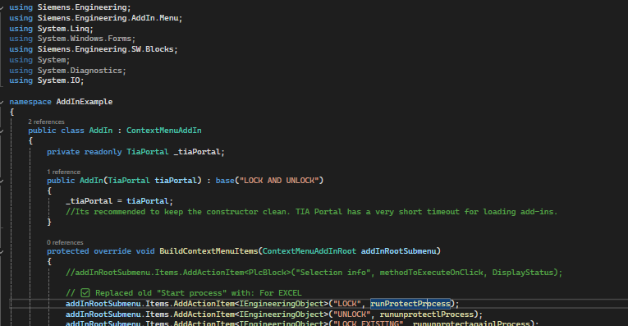
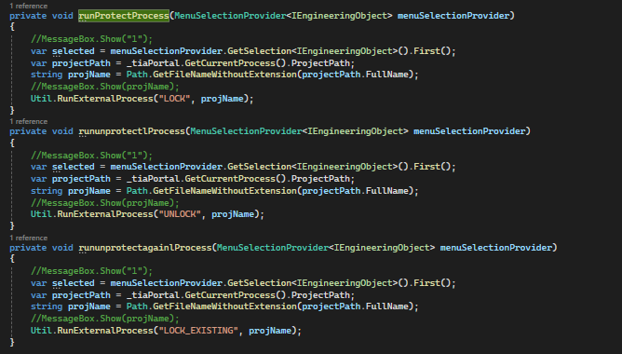
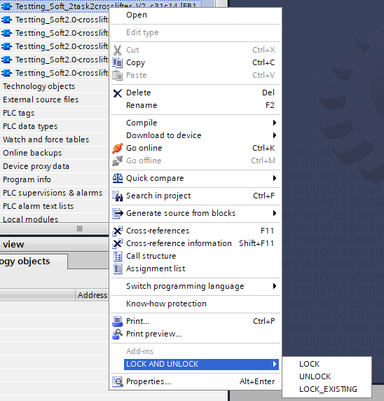
4. Program.cs – Block Protection Helper
Main Method
• Entry point of application
• Enables visual styles
• Validates license using LicenseManager
• Locates running TIA Portal process
• Hides TIA Portal window
• Executes LOCK / UNLOCK / LOCK_EXISTING actions
• Restores TIA Portal window
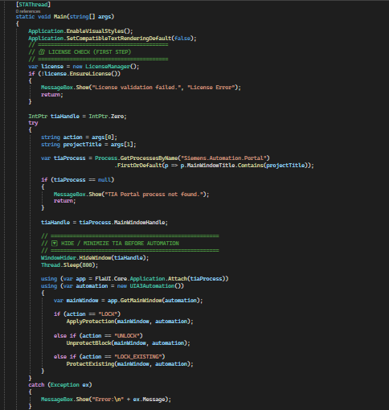
WindowHider
• Uses Win32 API (SetWindowPos)
• Hides TIA Portal window during automation
• Restores window after completion
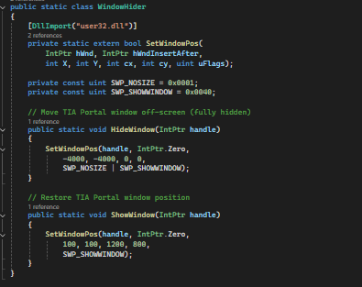
ApplyProtection
• Opens Protection tab
• Enables write protection
• Sets password via popup dialogs
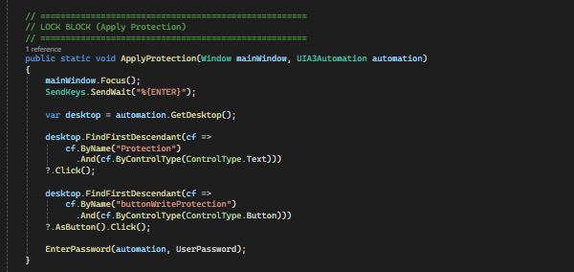
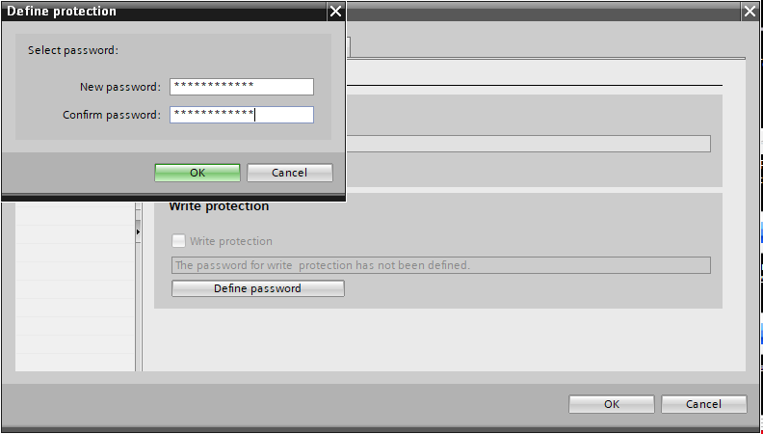
UnprotectBlock
• Opens Protection tab
• Disables write protection
• Confirms password
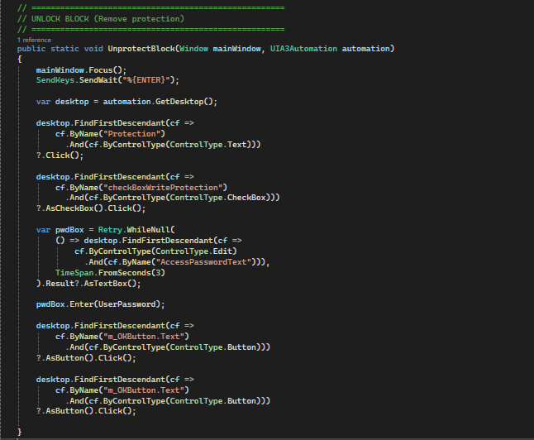
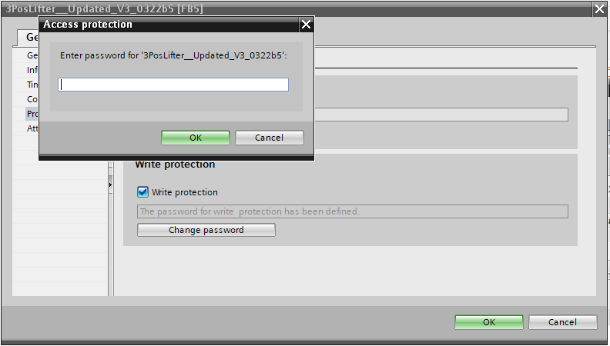

ProtectExisting
• Applies protection on already existing blocks
• Uses access password popup
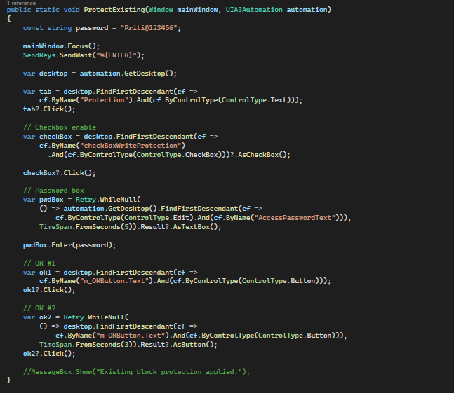
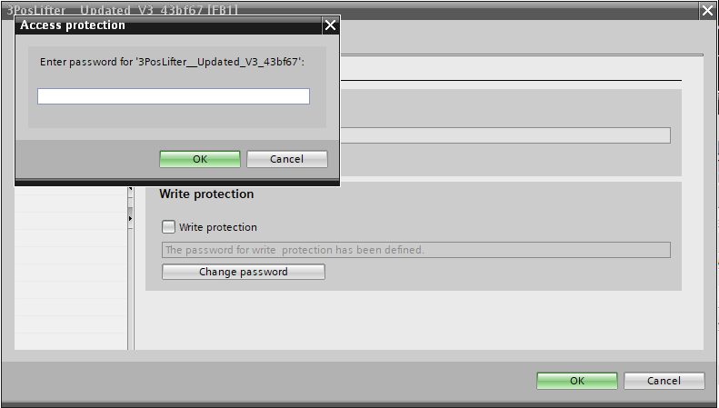
4. LicenseManager.cs – License Management
EnsureLicense
• Reads stored license
• Generates Application Key if missing
• Shows LicenseForm for Validation Key
• Verifies machine binding and expiry
Application Key Generation
• Based on MAC Address
• Machine Name
• Device Type
• Timestamp
• Converted to HEX format
Validation Key Verification
• Validates MAC & PC Name
• Checks expiry date
• Prevents usage on other machines
Data Storage
• License data stored in Data.dat
• Binary serialization used
5. LicenseForm UI
• Displays Application Key (Read-only)
• Accepts Validation Key input
• Register button validates input
• DialogResult used to return status
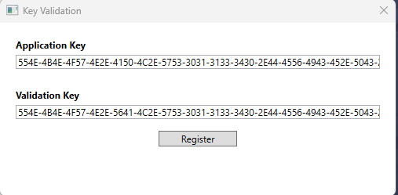
6. Execution Flow
1. Application starts
2. License validation executed
3. TIA Portal process detected
4. TIA window hidden
5. Block protection automation executed
6. TIA window restored
7. Application exits
7. Security Considerations
• Machine-bound licensing
• Password-protected block operations
• License expiry enforcement
8. Conclusion
This design ensures controlled automation of TIA Portal block protection with strict license enforcement and minimal user interaction.

